

Department of Computer Science and Engineering

Fall-2022

Course Code: CSE405

Course Title: Computer Networks

Section: 02

Project Report on

**Designing a full-fledged network for an organization with multiple subnets.**

**Submitted by:**

Name: Fahad Ahammed

ID: 2020-2-60-174

**Instructor:**

Dr. Anisur Rahman

Associate Professor

Department of Computer Science and Engineering

East West University

**Design a full-fledged network for an organization with multiple subnets**

**Description:**

University of Scholars, is an enterprise like East West University, owns many computers, with a complex network infrastructure. Apart from wired internet access to all the classrooms, labs, employee PCs, library and other administrative and academic wings, the university also provides wireless internet access for every campus. On top of that the university runs a complex networked systems to support several of its business process like admissions, advising, results, eTender, library management, accounts and so on.

This complex network infrastructure is subnetted and switching/routing mechanisms are in practice.

**Objective:**

Our goal is to create a complete model of a complex network by discovering the interconnectivity of the systems and subnetworks, which will reflect the University’s structure and facilities, features within the network will include the followings:

* Web page of the university will reflect University of Professionals’ web page.
* A single DNS sever needs to be installed to locate webserver - meaning people will browse University’s web site with the following address: http://www.scholars.edu.bd
* Configure the whole network in such a way that IP for the hosts of different campuses will be automatically assigned by a single DHCP server.
* Among the hosts in a network make sure some wireless hosts are added in addition to wired hosts.
* University’s full network has covered its seven campuses with seven routers
* Connectivity between all the hosts will be established.

**Features:**

* Network addresses will be from all 3 classes.
* Incorporation of different subnets.

**Requirements:**

1. 7 Router
2. 7 Switch
3. PC
4. Laptop
5. DHCP Server (Dynamic Host Configuration Protocol)
6. DNS Server (Domain name System)
7. WEB Server
8. Straight Through Cable
9. Serial DCE Cable

**Diagram:**

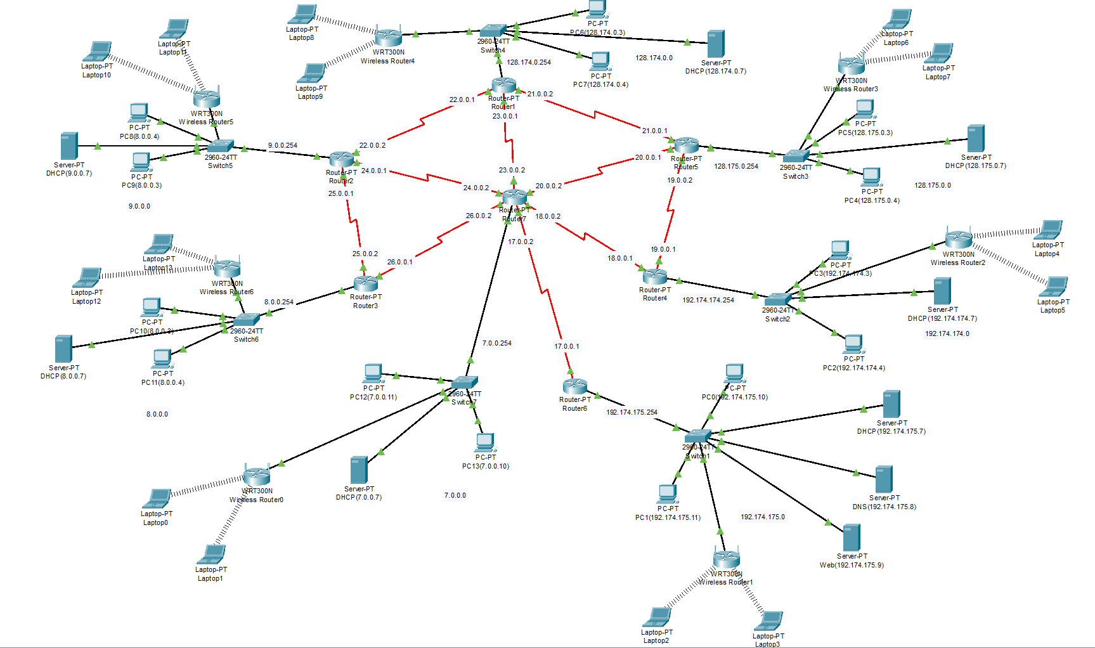

**University of Scholars Network**

**Campus Design and Configurations with Router**

**Campus 1:**

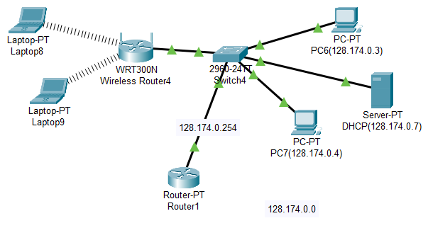

interface fa0/0

ip address 128.174.0.254 255.0.0.0

no shut

do wr

exit

interface se2/0

ip address 23.0.0.1 255.0.0.0

no shut

do wr

exit

interface se3/0

ip address 21.0.0.2 255.0.0.0

clock rate 64000

no shut

do wr

exit

interface se6/0

ip address 22.0.0.1 255.0.0.0

no shut

do wr

exit

router OSPF 1

network 22.0.0.0 0.255.255.255 area 1

network 23.0.0.0 0.255.255.255 area 1

network 21.0.0.0 0.255.255.255 area 1

network 128.174.0.0 0.0.255.255 area 1

exit

**Campus 2:**

interface fa0/0

ip address 9.0.0.254 255.0.0.0

no shut

do wr

exit

interface se2/0

ip address 22.0.0.2 255.0.0.0

no shut

do wr

exit

interface se3/0

ip address 24.0.0.1 255.0.0.0

clock rate 64000

no shut

do wr

exit

interface se6/0

ip address 25.0.0.1 255.0.0.0

no shut

do wr

exit

router OSPF 2

network 22.0.0.0 0.255.255.255 area 1

network 24.0.0.0 0.255.255.255 area 1

network 25.0.0.0 0.255.255.255 area 1

network 9.0.0.0 0.0.255.255 area 1

exit

**Campus 3:**

interface fa0/0

ip address 8.0.0.254 255.0.0.0

no shut

do wr

exit

interface se2/0

ip address 26.0.0.1 255.0.0.0

no shut

do wr

exit

interface se3/0

ip address 25.0.0.2 255.0.0.0

clock rate 64000

no shut

do wr

exit

router OSPF 3

network 8.0.0.0 0.255.255.255 area 1

network 26.0.0.0 0.255.255.255 area 1

network 25.0.0.0 0.255.255.255 area 1

exit

**Campus 4:**

interface fa0/0

ip address 192.174.175.254 255.255.255.0

no shut

do wr

exit

interface se2/0

ip address 19.0.0.1 255.0.0.0

no shut

do wr

exit

interface se3/0

ip address 18.0.0.1 255.0.0.0

clock rate 64000

no shut

do wr

exit

router OSPF 4

network 18.0.0.0 0.255.255.255 area 1

network 19.0.0.0 0.255.255.255 area 1

network 192.174.175.0 0.0.0.255 area 1

exit

**Campus 5:**

interface fa0/0

ip address 128.175.0.254 255.255.0.0

no shut

do wr

exit

interface se2/0

ip address 21.0.0.1 255.0.0.0

no shut

do wr

exit

interface se3/0

ip address 20.0.0.1 255.0.0.0

clock rate 64000

no shut

do wr

exit

interface se6/0

ip address 19.0.0.2 255.0.0.0

no shut

do wr

exit

router OSPF 5

network 21.0.0.0 0.255.255.255 area 1

network 19.0.0.0 0.255.255.255 area 1

network 128.175.0.0 0.0.255.255 area 1

network 20.0.0.0 0.0.255.255 area 1

exit

**Campus 6:**

interface fa0/0

ip address 192.174.175.254 255.255.255.0

no shut

do wr

exit

interface se2/0

ip address 17.0.0.1 255.0.0.0

no shut

do wr

exit

router OSPF 6

network 192.174.175.0 0.0.0.255 area 1

network 17.0.0.0 0.255.255.255 area 1

exit

**Campus 7:**

interface fa0/0

ip address 7.0.0.254 255.0.0.0

no shut

do wr

exit

interface se2/0

ip address 23.0.0.2 255.0.0.0

no shut

do wr

exit

interface se3/0

ip address 20.0.0.2 255.0.0.0

clock rate 64000

no shut

do wr

exit

interface se6/0

ip address 18.0.0.2 255.0.0.0

no shut

do wr

exit

interface se7/0

ip address 17.0.0.2 255.0.0.0

no shut

do wr

exit

interface se8/0

ip address 24.0.0.2 255.0.0.0

no shut

do wr

exit

interface se9/0

ip address 26.0.0.2 255.0.0.0

no shut

do wr

exit

router OSPF 7

network 7.0.0.0 0.255.255.255 area 1

network 23.0.0.0 0.255.255.255 area 1

network 20.0.0.0 0.255.255.255 area 1

network 18.0.0.0 0.255.255.255 area 1

network 17.0.0.0 0.255.255.255 area 1

network 24.0.0.0 0.255.255.255 area 1

network 26.0.0.0 0.255.255.255 area 1

exit

**Website**

**PC:**

**DNS:**

**DHCP:**

**WEB:**

**Conclusion:**

In conclusion, university network systems play a crucial role in the functioning and operation of modern educational institutions. These systems provide students, faculty, and staff with access to important information and resources, such as class schedules, online course materials, and email. They also enable communication and collaboration among members of the university community, as well as facilitate administrative tasks such as grading and record-keeping.

Overall, a well-designed and properly maintained university network system is essential for the success and efficiency of any educational institution.